1. Say, we’re creating database for our hospital app where we have got patients and disease summary.   
   Every patient has a disease summary that belongs to that patient only such as   
    is ill, had previous disease, and a list of previous diseases etc.
2. Of course, this is one to one relationship.
3. How to model that?
4. 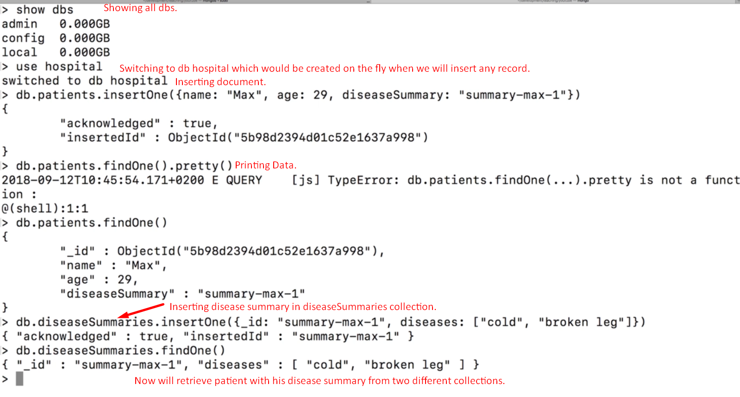
5. 